**Creality Stepper Motor - 12V Hi-torque NEM 42x34mm 1.8° step**

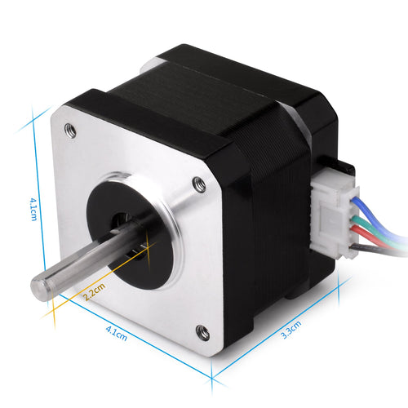**Description**

Most popular Nema 17 model with 1.8 deg. step angle (200 steps/revolution)

Each phase draws the current 0.4 A at 12V, allowing for a holding torque of 26Ncm(36.8oz.in).

**Electrical Specification:**

Motor Type: Bipolar Stepper

Step Angle: 1.8°

Holding Torque: 26Ncm(36.8oz.in)

Rated Current/phase: 0.4A

Phase Resistance: 30ohms

Inductance: 37mH+/-20%(1KHz)

**Physical Specification:**

Cable length: 11.8 inches.

Frame Size: 42 x 42mm

Body Length: 34mm

Shaft Diameter: 5mm

Front Shaft Length: 20mm

D-cut Length: 15mm

Number of Leads: 4

Lead Length: 300mm

Weight: 230g

**Connection:**

Black(A+), Green(A-), Red(B+), Blue(B-)

**Warning:**

Make sure the motor connects to a constant current or chopper drive controller before you test the motor. Connecting the motor directly to a power supply will destroy the motor.

**SKU:** 4004100024